Rev. Dr. Robert “Rob” White

“Rob is a Child of God. Rob is a husband and father. Rob is a friend and a pastor....in that order.” This is how Rob describes himself on his website.  Rob is married to Tracy Flores, whom he met while serving as youth director (2005-2009) at First Presbyterian in Vero Beach, Florida. They were married in 2008. They have two children: Liam, who is 12, and Adalyn, who is 9. | 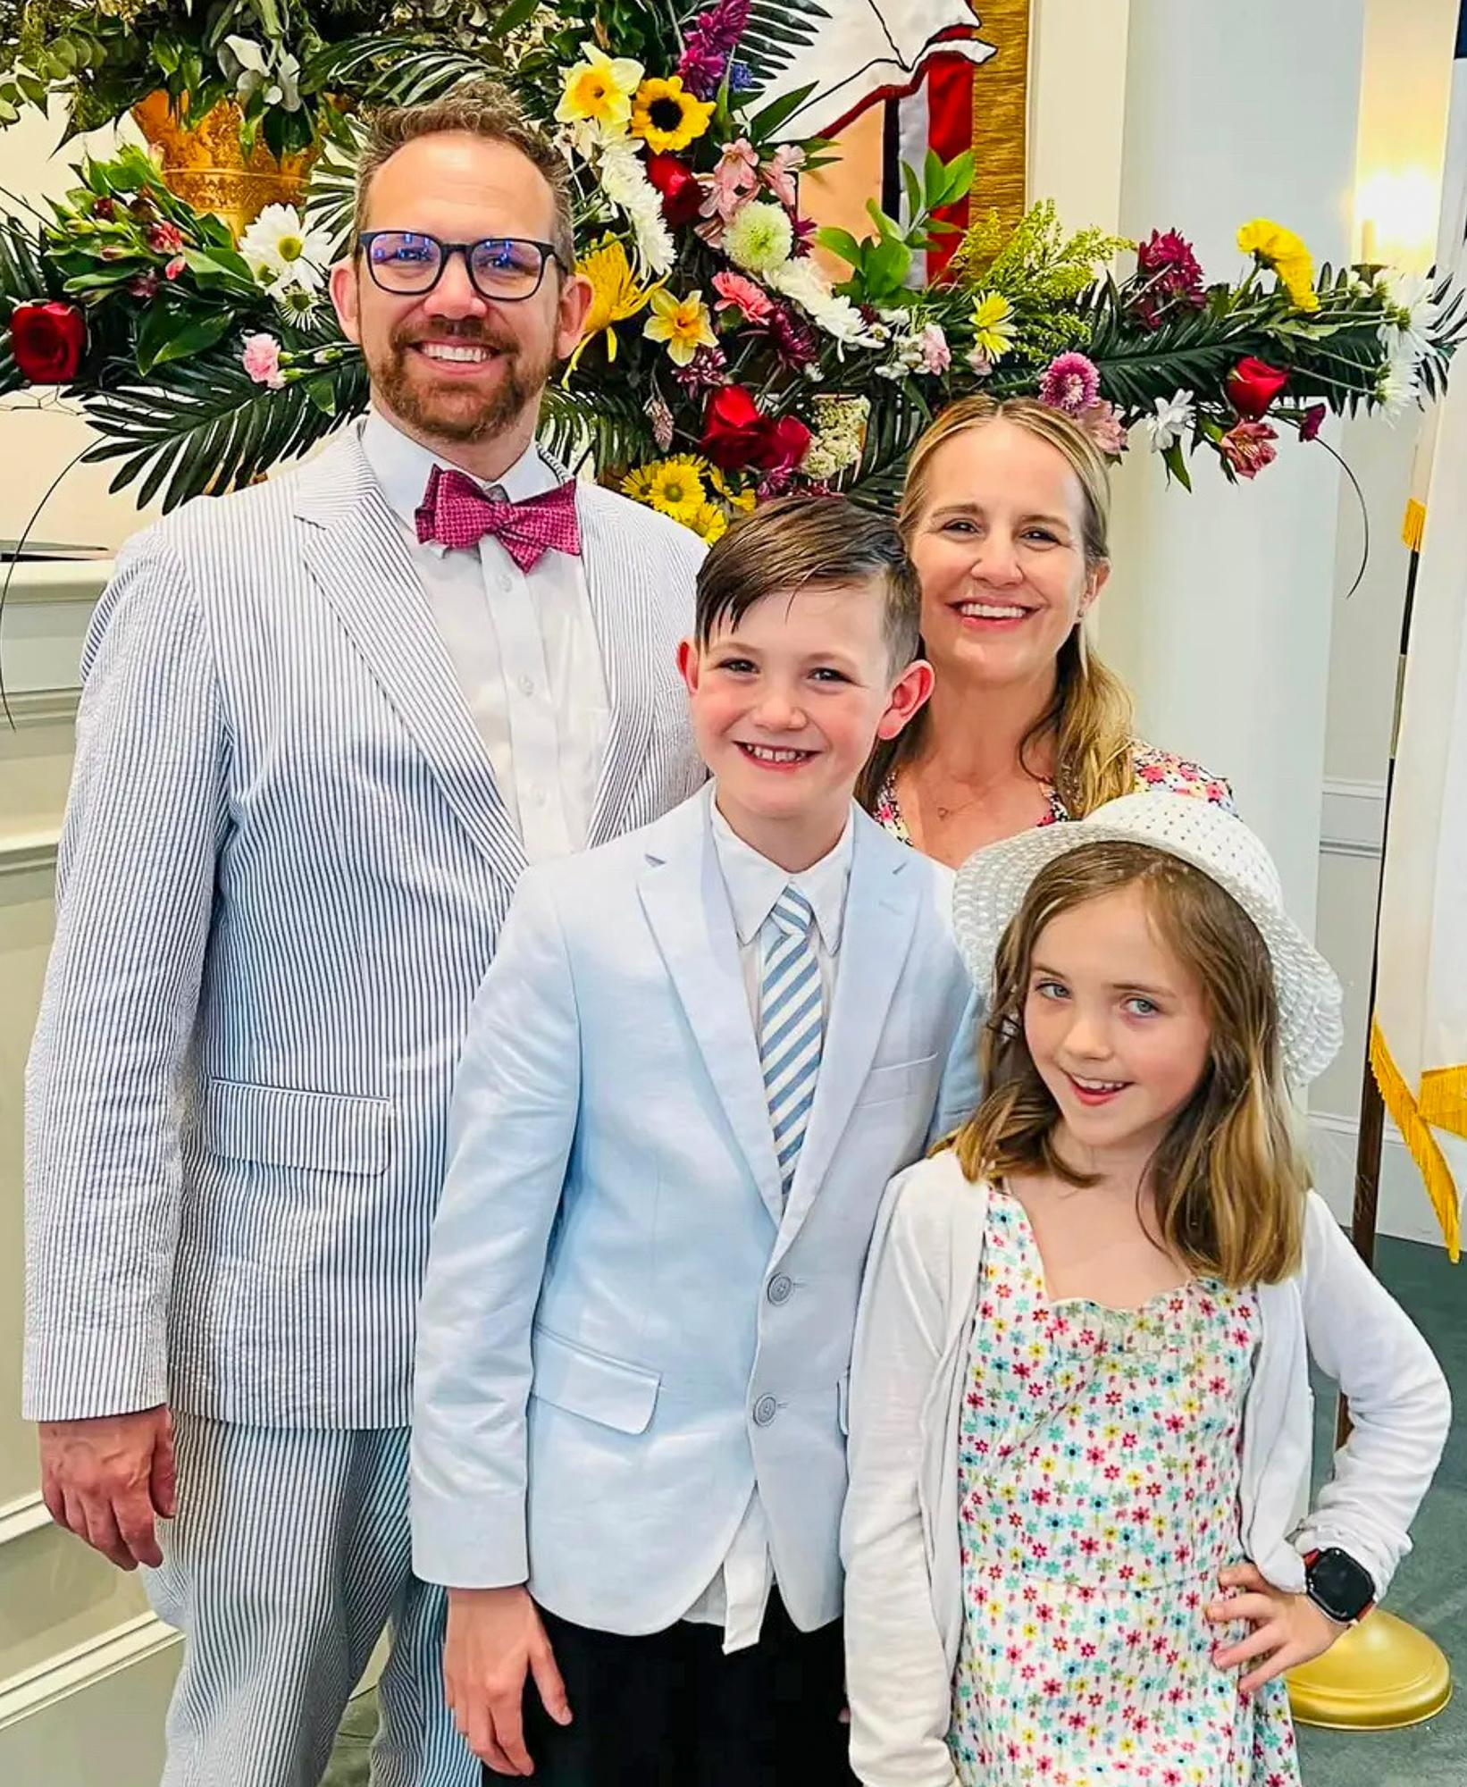
Rob comes to us from First Presbyterian Church, Hernando, MS., where he has been the head of staff and senior pastor since 2017. Prior to that, he was Head of Staff at Covington Presbyterian Church in Louisiana for five years. Rob has also worked with churches in Tennessee, Arkansas, Florida, and Georgia where he served in a variety of roles from Clinical Pastoral Education Intern, a Pastoral Intern, a Coordinator of Youth and Young Adult Ministries, and a camp director.

Rob received a Doctorate of Ministry in Preaching from McCormick Theological Seminary/ Association for Chicago Theological Seminaries, where his dissertation was “Forward to the Past: Preaching as a Tool to Re-establish Congregational Identity”. He received his Master of Divinity from Columbia Theological Seminary, and received a Bachelor of Science from Arkansas State University.

Rob believes that his whole career has been building to this moment, preparing him to serve God at Eastminster. The members of the Pastor Nominating Committee agree and have found Rob to be full of God’s love and possessing endless energy!

